## Silence for Seven Minutes of World Peace

## International Day of Peace

## Ringing of the Peace Bell at the UN

To answer queries related to 3 items above, I put together information from various sources on past results that might be of interest to those planning future events…

## Silence for Seven Minutes of World Peace

Initiated in 1984, people around the world shared seven minutes of **silence for peace** at the exact same moment on United Nations Day, 24 October, at the local time corresponding to 17.00 – 17.07 hours Greenwich Mean Time (1pm New York Time). The event sought to focus the world’s attention on the urgent need for peace in the international and interfaith spirit of the United Nations. It had no political affiliation or purpose other than to work toward and strengthen the universal human aspiration for harmony, peace and oneness among nations and peoples.

The local observances were sponsored by non-governmental organizations, United Nations Associations and others in cooperation with “Sri Chinmoy: The Peace Meditation at the United Nations”. People were invited to join individually or in groups and to register their participation.

|  |  |
| --- | --- |
| A**s of 2019 a Seven Minutes for World Peace event** which was originally observed since 1984 to coincide with UN Day 24 October, was celebrated in various countries with a revised format, to call attention to the UN General Assembly proclaimed “International Day of Peace”, 21 September (*see also historical note on IDP)    **Seven Minutes of Silence for peace** over many years also took place in various Secretariat offices periodically, in some cases weekly, and in several cases, daily. | 1984-10-24-03-seven-minutes-for-world-peace-Sri-Chinmoy-leads-meditation-UN-conference-room-crp4.jpg 998 KB use crp 2? |

|  |  |
| --- | --- |
| Inspiring examples of participation:   * In Sri Lanka, the United Nations Association included Seven Minutes observances in their planned 1985 UN Day event. Over 70,000 people joined in 1986, and millions in subsequent years; * In the former Soviet Union, in 1994, extensive radio and newspaper announcements inspired over 20,000 individuals to hold group or personal observances in 47 cities.] … | 1985-10-oct-24-seven-min-world-peace-sri-lanka-scaled.jpg – 571 KB |

|  |
| --- |
| 1985-10-oct-24-seven-min-world-peace-sri-lanka-flags-2 |
| **1985-10-oct-24-seven-min-world-peace-sample-city-proclamations_Page_7** |

### Some history on the 7 min part over the years: Seven Minutes for World Peace

The **seven minutes of Silence** allow all to join a shared aspiration that can be preceded or followed by whatever the local situation, faiths or meditation groups presented. It set out a **main 7-minute quiet time** to include all. This also welcomed and encouraged those with no professed religious faith or belief to join the silent experience.

**As mentioned above**,

A**s of 2019 a Seven Minutes for World Peace event** which was originally observed since 1984 to coincide with UN Day 24 October, was celebrated in various countries with a revised format, to call attention to the UN General Assembly proclaimed “International Day of Peace” (IDP), 21 September (*see also historical note on IDP)

**Seven Minutes of Silence for peace** over many years also took place in various Secretariat offices periodically, in some cases weekly, and in several cases, daily.

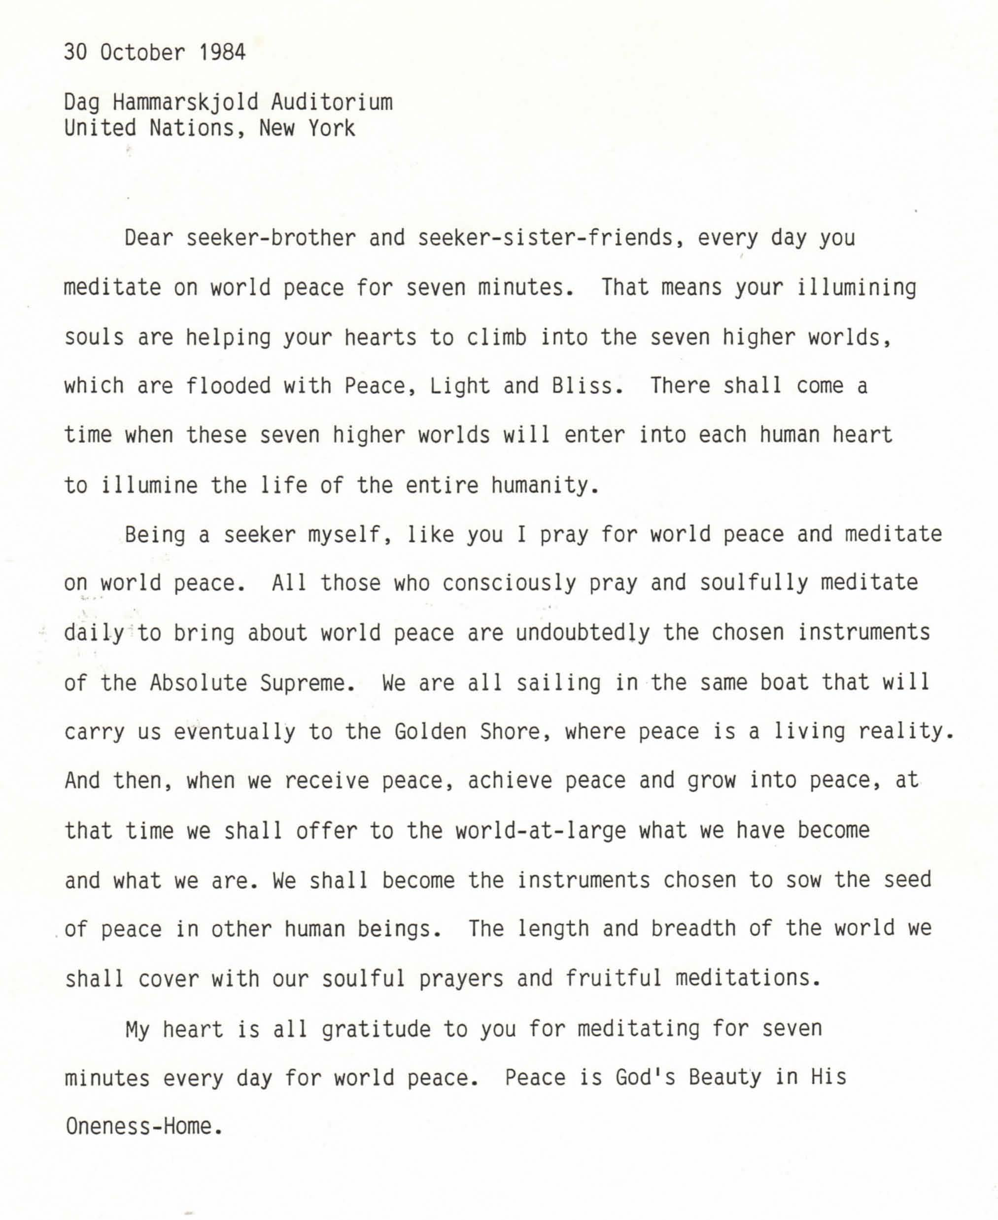

Below are scans of **sample announcements** etc. which **show how the day was presented** various years.

## Examples of Seven Minutes of Silence: Shared announcements, invitations, background:

|  |
| --- |
| **1984-10-oct-24**-seven-min-world-peace-invite-delegate-and-staff-QUOTE-Silent-Prayer-or-Meditation |
| **1985-10-oct-24-seven**-min-world-peace-11in_Page_2-QUOTE-Global-Experience-Silence-maybe-for-1986 |

|  |
| --- |
| 1985-10-oct-24-seven-min-world-peace-summary |
| 1985-oct-24-7-minutes-peace-brochure-ocr-opt_Page_2 |

|  |
| --- |
| **1986-10-oct-24-seven-minutes**-silence-for-peace-invite_Page_5-QUOTE-silently-dedicating-themselves |
| **1****989-10-oct-24-**un-day-seven-min-peace_Page_1-QUOTE-simultaneously-maintain-silence |

|  |
| --- |
| **1989-10-oct-24**-un-day-seven-min-peace_Page_4 |
| **1991-10-0ct-24-seven**-minutes-for-world-peace-announce |

# Notes pm International Day of Peace and Ringing of Peace Bell:

*The date of the International Day of Peace fell on the third Tuesday of September most years ,(which was usually the opening day of the UN General Assembly) Some years that varied until 2002, when the date was fixed as 21 September each year by the UN General Assembly. See Part 3-03? UN Anniversaries for details on dates and history.

* fuller description is I Part 3-03 reproduced here with understanding that both could reference a single End Note fr Prt 3- events.

## *International Day of Peace (IDP) – Now 21 Sept

Each year the International Day of Peace is observed around the world on 21 September (An alternate date near 21 Sep in accord with local preferences and custom has sometimes been chosen) . The UN General Assembly has declared this as a day devoted to strengthening the ideals of peace, through observing 24 hours of non-violence and cease-fire.

### Background

The International Day of Peace was [established](http://undocs.org/A/RES/36/67) in 1981 by the UN General Assembly. It was first celebrated to coincide with the opening of the General Assembly Session each year (third Tuesday of September). Two decades later, in 2001, the General Assembly unanimously voted to move the Day to 21 September as a period of non-violence and cease-fire.

The United Nations invites all nations and people to honour a cessation of hostilities during the Day, and to otherwise commemorate the Day through education and public awareness on issues related to peace.

## Peace Bell

One of the days the Peace Bell is rung during a ceremony at UN Headquarter in NY, is to announce that year's International Day of Peace. Sometimes it is observed a few days in advance of September 21. The Peace Bell was donated by the UN Association of Japan in June 1954. The actual date for the Bell ringing event is adjusted based on UN activities planned for that time frame.

|  |  |  |
| --- | --- | --- |
| **1971-03-21**-mar-SG**-U-Thant-before-ring-Peace-Bell-UN-NY-ceremony-“Earth-Day**”UN-photo-240556-crp | 2020-09-17-sep-Melissa-Fleming-left-USGs-remarks-SG-Antonio-Guterres-on-right-Peace-Bell-ceremony-UN-HQ-un-photo-845400-crp | 2020-09-17-sep-SG-António-Guterres-rings-Peace-Bell-UN-NY_HQ-in-advance-Internat-Day-Peace-UN-photo-845461 |

]

|  |  |
| --- | --- |
| 3.Invites all member states, organs and organizations of the United Nations system, regional organizations, non-governmental organizations, peoples and individuals to commemorate in an appropriate manner the International Day of Peace, especially through all means of education, and to co-operate with the United Nations in the observance of that Day. – 77th Plenary meeting 30 November 1983. UNGA –A-Res-36-67 |  |

undocs.org-A-RES-36-67-GA res-international-year-day-of-peace-Participation[/caption]

**Day moved to 21 September for 2003 observance**. It was previously celebrated to coincide with the Opening for the General Assembly on the Third Tuesday of September.

**A/RES/55/28223  International Day of Peace** The General Assembly, Recalling its resolution 36/67 of 30 November 1981, by which it declared that the third Tuesday of September, the opening day of the regular sessions of the General Assembly, shall be officially proclaimed and observed as International Day of Peace and shall be devoted to commemorating and strengthening the ideals of peace both within and among all nations and peoples, ... achieving the broadest possible awareness and observance of the International Day of Peace among the global community, Desiring to **draw attention to the objectives of the International Day of Peace, and therefore to fix a date for its observance each year that is separate from the opening day of the regular sessions of the General Assembly**,

1.Decides that, with effect from the fifty-seventh session of the General Assembly,(2003)  t**he International Day of Peace shall be observed on 21 September each year,** with this date to be brought to the attention of all people for the celebration and observance of peace;

2.Declares that the International Day of Peace shall henceforth be observed as a day of global ceasefire and non-violence, an **invitation to all nations and people to honour a cessation of hostilities for the duration of the Day; .Invites all Member States, organizations of the United Nations system, regional and non-governmental organizations and individuals to commemorate, in an appropriate manner**, the International Day of Peace, including through education and public awareness, and to cooperate with the United Nations in the establishment of the global ceasefire.111th plenary meeting7 September 2001

### UN related Documents

[General Assembly Resolution on International Year of Peace and International Day of Peace (A/RES/36/67)](http://undocs.org/A/RES/36/67)

[General Assembly Resolution on International Day of Peace (A/RES/55/282)](http://undocs.org/A/RES/55/282)