**Commemoration Opening 30th Session UN General Assembly 12 Sep 1975 – Interfaith**

“The Quintessence of Divinity in Humanity: International Cooperation for Peace. “

**Inspired by the observance of a “Minute of Silent Prayer or Meditation” at the opening of each United Nations General Assembly,**

the Meditation Group at the U.N. co-sponsored a special programme to commemorate the opening of the thirtieth session of the General Assembly, in a spirit of rededication to the lofty aims and ideals of the United Nations. The programme, which was held in Conference Room 3 on Friday, September 12, 1975, was attended by delegates, Secretariat staff members and NGO representatives.

Sri Chinmoy opened the programme with a silent meditation, then sang a song, accompanying himself on the harmonium:

|  |  |
| --- | --- |
|  | * *In 1939, the hope for the League of Nations was smashed by yet another world war.* * *In 1945 , the emergence of the United Nations provided the world with a means of international development.* * *The League of Nations did not fail because of its principles and conceptions. It failed because these principles were deserted by those States which had brought it into being . .. This disaster must not be repeated*. – Winston Churchill, 1946   It is with this responsibility in mind that now, with the opening of the 30th Session of the United Nations General Assembly , we meet to reaffirm those aims and goals of the United Nations – those principles by which we can guide ourselves to  “***The Quintessence of Divinity in Humanity: International Cooperation for Peace. “*** |

**CHARTER OF THE UNITED NATIONS**

*WE THE PEOPLES OF THE UNITED NATIONS*  
*determined to save succeeding generations from the scourge of war, which twice in our lifetime has brought untold sorrow to mankind, and to reaffirm faith in fundamental human rights, in* *the dignity afld worth of the human person, in the equal rights of men and women and of nations large and small, and to establish conditions under which justice and respect for the obligations arising from treaties and other sources of international law can be maintained, and to promote social progress and better standards of life in larger freedom,*  
*and for these ends*  
*to practice tolerance and live together in peace with one another as good neighbours, and*  
*to unite our strength to maintain international peace and security, and*  
*to ensure, by the acceptance of principles and the institution of methods, that armed force shall not be used, save in the common interest, and*  
*to employ international machinery for the promotion of the economic and social advancement of all peoples,*  
*have resolved to combine our efforts to accomplish these aims*

*Accordingly, our respective Governments, through representatives assembled in the city of San Francisco, who have exhibited their full powers found to be in good and due form, have agreed to the present Charter of the United Nations and do hereby establish an international organisation to be known as the United Nations.*

**INTRODUCTION**  
In observance of that invitation to silent prayer and meditation which  follows each Opening of the United Nations General Assembly, we offer our commemorative ceremony to the success of the United Nations and the progress of humanity.

Conference Room 3, Friday, September 12, 1975,  (for delegates, Secretariat  staff members and NGO representatives).

* **Sri Chinmoy** opened the programme with a silent meditation and song.

[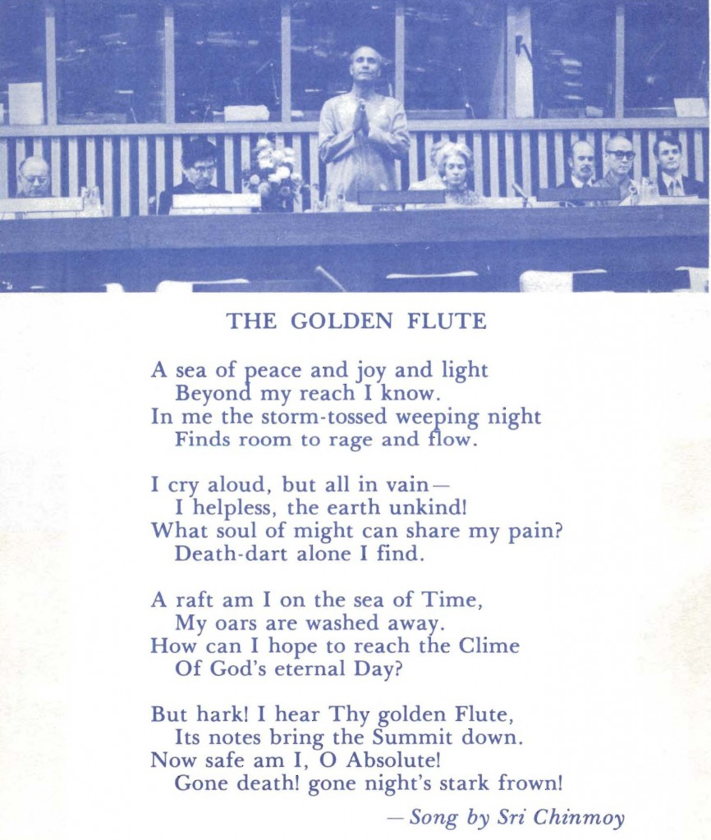](https://www.srichinmoypeacemeditationatun.org/wp-content/uploads/1975/09/bu-scpmaun-1975-09-12-30th-open-unga_P03-open-med-song-ckg.jpg)

**Participating guest-speakers** offered their prayerful contributions

* + **NORMA LEVITT**, Co-Chairperson, World Union for Progressive Judaism
  + **REVEREND JIH TSANG**, Assistant Abbot, Temple of Enlightenment
  + **MUDDASSIR ALI SHAMSEE**, Leader, Muslim Prayer Group, United Nations.
  + **REVEREND DR. DAN POTTER**, Executive Director, Council of Churches, City of New York
* EXCERPTS on the topic “*The Quintessence of Divinity in Humanity: International Cooperation for Peace.* ”
  + -**MR. DAVID S. BURGESS**, Senior Officer, United Nations International Children’s Fund
  + **MR. DONALD KEYS**, United Nations Representative of the World Association of World Federalists

Statement by Secretary-General Waldheim For commemorative programme .

Singing the **song “O United Nations”** which Sri Chinmoy recently wrote in **dedication to the United Nation**s:

**Choral reading** based on excerpts from the writings of past Secretaries-General of the United Nations:

* Trygve Lie
* Dag Hammarskjold
* U Thant

In conclusion, silent rededication to the highest goals of the United Nations

Article in the ***Diplomatic World*** on 06 October 1975,  [***Major Faiths In Program*** to mark the opening of the 30th General Assembly.](https://www.srichinmoypeacemeditationatun.org/wp-content/uploads/1975/09/bu-scpmaun-1975-09-27-vol-03-n-09-sep_P25-dip-world-major-faiths.jpg)

– – – – – – – – – – –  –  – –  Details Below – – – – – – – – – –  – – – – – – –

**Participating guest-speakers** offered their prayerful contributions

[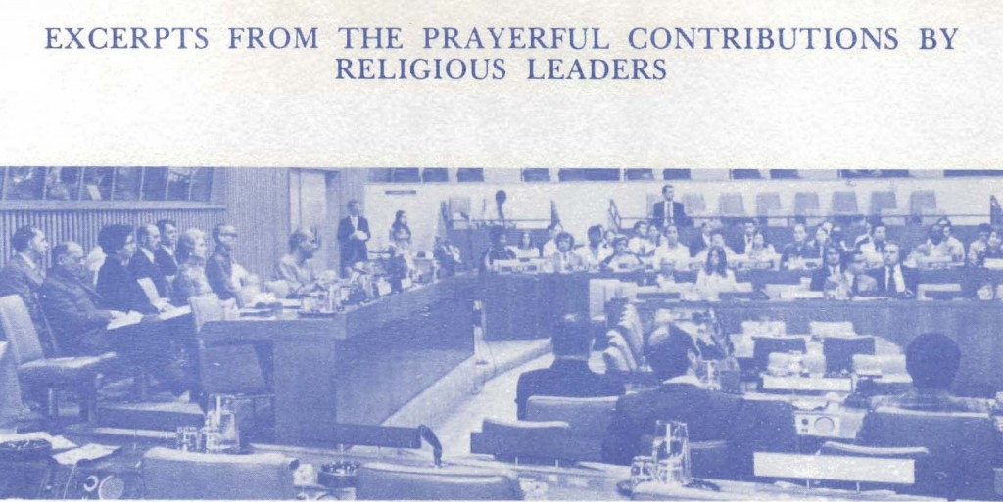](https://www.srichinmoypeacemeditationatun.org/wp-content/uploads/1975/09/bu-scpmaun-1975-09-12-30th-open-unga_P04-group-dias.jpg)

* + **NORMA LEVITT**, Co-Chairperson, World Union for Progressive Judaism[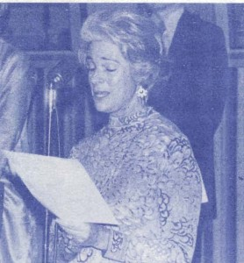](https://www.srichinmoypeacemeditationatun.org/wp-content/uploads/1975/09/bu-scpmaun-1975-09-12-30th-open-unga_P04-norma-levitt-prog-judaism.jpg)*“[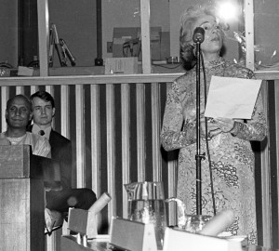](https://www.srichinmoypeacemeditationatun.org/wp-content/uploads/1975/09/75-89A-02-crp.jpg) . .. In these days of contemplation, we render an account of our lives and actions before the Supreme Judge. We yearn for sustained hope, unyielding faith and spiritual regeneration, as we look not only inward at ourselves, but also outward at the world in which we live.*  
    *We pray that all nations and all peoples shall strive together, shall sacrifice if necessary, for a world community of justice, development, harmony and peace … . “*  
    *Amen*

* **REVEREND JIH TSANG**, Assistant Abbot, Temple of Enlightenment[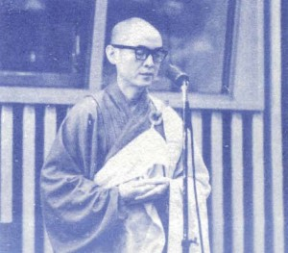](https://www.srichinmoypeacemeditationatun.org/wp-content/uploads/1975/09/bu-scpmaun-1975-09-12-30th-open-unga_P04-jih-tsang-buddha-temp-enlight.jpg)*“[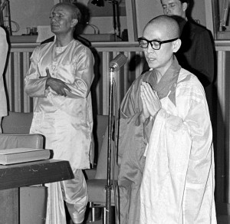](https://www.srichinmoypeacemeditationatun.org/wp-content/uploads/1975/09/75-89A-21-buddhist.jpg) . .. Buddha, the Enlightened, in His Light, let us spread and plant the seeds of harmony, happiness and peace …..”*

* + **MUDDASSIR ALI SHAMSEE**, Leader, Muslim Prayer Group, United Nations.[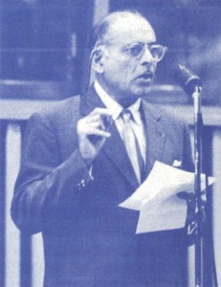](https://www.srichinmoypeacemeditationatun.org/wp-content/uploads/1975/09/bu-scpmaun-1975-09-12-30th-open-unga_P05-ali-shamsee-muslim-prayer-grp.jpg)*“[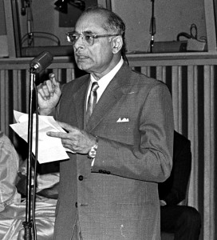](https://www.srichinmoypeacemeditationatun.org/wp-content/uploads/1975/09/75-89A-23-crp.jpg) … I believe in what God has revealed in all the scriptures . . . that mankind can unite best in faith in one Creator, one Master, God Almighty; that there must be justice, without which no peace can be created or can be lost; that there must be respect for others and tolerance; that there must always be the hope that in spite of differences, eventually mankind will unite . .. Competition is recognised but not in making others*  
    *subservient, … but in doing good to others and being virtuous.*  
    *” . . . 1 thank God for all the goods things that He has given to mankind, may He give us the wisdom and breadth of heart that these we may share . .. . “*

* + **REVEREND DR. DAN POTTER**, Executive Director, Council of Churches, City of New York[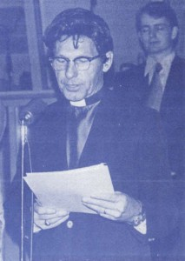](https://www.srichinmoypeacemeditationatun.org/wp-content/uploads/1975/09/bu-scpmaun-1975-09-12-30th-open-unga_P05-dan-potter-council-churches-nyc.jpg) [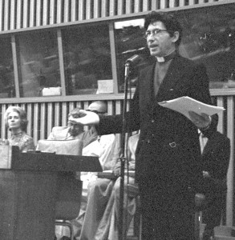](https://www.srichinmoypeacemeditationatun.org/wp-content/uploads/1975/09/75-89B-27-rev-potter.jpg)“Almighty and gracious God, … We pause humbly at the celebration of the 30th Session of the United Nations General Assembly, to acknowledge You as the Source of all creation, all that we are, all that we have, and especially today to acknowledge You as the Source of the inspiration that brought forth the United Nations Charter. We thank You and praise You for the high and lofty principles that have brought the differing nations of the world together. .. Bless, we pray You, every nation in the United Nations, the delegates and their families from all over the world, the staff and the volunteers, the leaders and the helpers, the powerful and the weak, the great and the small…. ”  
    Amen
* **EXCERPTS on the topic “*The Quintessence of Divinity in Humanity:***

***International Cooperation for Peace.* “**  
**-**

* + **MR. DAVID S. BURGESS**, Senior Officer, United Nations Children’s Fund (UNICEF)[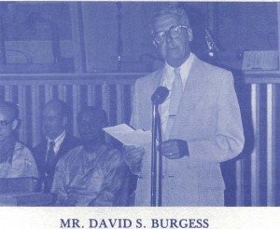](https://www.srichinmoypeacemeditationatun.org/wp-content/uploads/1975/09/bu-scpmaun-1975-09-12-30th-open-unga_P06-david-burgess-unicef.jpg)“[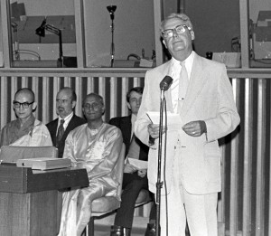](https://www.srichinmoypeacemeditationatun.org/wp-content/uploads/1975/09/75-89A-18-d-beerman-unief.jpg) *… For those of us participating in the Seventh Special Session of the United Nations, those of you who will participate in the 30th Session of the General Assembly, for those of us who work in the Secretariat and in various agencies of the United Nations, key words of the past few years have taken on new meaning- détente, pollution, national identity,  determination, apartheid, multinational corporations, hunger, disaster, human rights, liberation, imperialism, confrontation –*  
    *Those of us working in this great metal structure on the East River, … we who are emersed in papers, in our duties, in making speeches … we feel lost. We feel lost because these words confront the ultimate questions of life on earth, the quality of life, the very fragile future of humanity itself ….*  
    *Unless we consider our ways, there is no future for any óf us. We need the sharing of knowledge, the exploration for new sources of energy, a willingness to consider limits to the high standards of living so that others. may have … a decent future. Whether we are nations that deal with the secular fate, or nations of the church state, it matters not. The ultimate questions are before us all … Those nations who are powerful today may be lost kingdoms of tomorrow, unless we recognise our human interdependence . . .unless we consider our ways.*  
    *The greatness of the United Nations is that we, in our human and failing ways, are attempting to deal with the ultimate questions of survival. .. the final Armageddon .*  
    *… There is hope, there is hope no matter from which nation we come, but only if we come to realise our interdependence, our mutual closeness … our rights to the basic principIes of distributive justice .. .. “*
  + **MR. DONALD KEYS**, United Nations Representative of the World Association of World Federalists

|  |  |
| --- | --- |
|  | * + *Mankind is on. the verge of taking its next big step … a step in awareness, a step in consciousness, a step in perspective, a step in relationships.* *There was a time when mankind thought the world was flat.* *There was a time when mankind felt the earth was the centre of the solar system.* *There was a time when man believed that the clan was the ultimate social organisation.* *There was a time when the problems of the city·state were the ultimate in social organisation.* |

* + *“    We have been living in a time when man has regarded as the ultimate social institution, the nation-state. That time is now rapidly passing, and we are in the throes of a new Copernican revolution in which man will come to regard, naturally and normally, that the planet is the basis of social organisation and inter-relationship … This is the new pragmatic reality.*  
    *In the Sixth Special Session, that reality was glimpsed close up from the framework of confrontation. In the Seventh Special Session that reality began to emerge as confluence, cooperation and convergence. The road from here to there, the road to the unification of the human species, will be a long road. But the 30th Assembly Session of the United Nations will, without doubt, see a substantial acceleration in that convergent process. Nations will*  
    *find a new relationship in a common organism … that organism will be the united body O mankind … And it is the spirit of the United Nations which stands for that unification process … that will make possible what men have so long desired.*  
    *We are part witnesses, part authors, part participants, part instruments in this process. We hope that we may play those parts with increased understanding and increased effectiveness.”*

**Statement by Secretary-General Waldheim For commemorative programme .**

Message from Secretary-General Kurt Waldheim-written for the occasion of the General Assembly Commemoration Programme 12 September 1975 .

*At the beginning of the 30th Session of the General Assembly, we are given the opportunity to look back upon the achievements of the world Orgamzation over the past thirty years. In spite of many difficulties and some disappointments, we have created a unique human institution, which is now approaching full universality of membership, and which has proved capable of change as well as of expansion Today, it is more relevant than it has ever been to the challenges and opportunities of the world.*

*The potential of the United Nations is immense. What is required is a renewal of our common faith and determination that the advances of the past thirty years will be maintained and that we will, together, meet the challenges of our times. In this vital work, I ask for your support, encouragement and assistance.*

*But this occasion also provides us with the opportunity of look¡ng forward. We know that mankind faces many grave and*  
*complex problems. The uses of peace and war, of Plenty and of poverty, of justice and injustice, still confront us and must be* *resolved.*

Singing the **song “O United Nations”** which Sri Chinmoy recently wrote in **dedication to the United Nation**s:

|  |  |
| --- | --- |
|  | *O United Nations, O U.N.* *You are the world-body* *Crying for the world-soul.* *And you are the earth-life* *Longing for oneness-goal.*  *In the heart of your glowing dream,* *Big brothers and brothers small* *Shall smile, sing and dance –* *O Vision-Perfection in all.* |

Meditation Group singing “O United Nations”

|  |  |
| --- | --- |
|  |  |

|  |  |
| --- | --- |
| **Choral reading** based on excerpts from the writings of past Secretaries-General of the United Nations: |  |

|  |  |  |
| --- | --- | --- |
| Trygve Lie |  | * + ” … The one common undertaking and universal instrument of the great majority of the human race is the United Nations. A patient, constructive, long-term use of its potentialities can bring a real and secure peace to the world …. ”  – Trygve Lie |

|  |  |  |
| --- | --- | --- |
| Dag Hammarskjold |  | “ *… But common to us all, and above all other convictions stands the truth, once expressed by a Swedish poet when he said that the greatest prayer of man does not ask for victory but for peace.”* – Dag Hammarskjold |

|  |  |  |
| --- | --- | --- |
| U Thant |  | ” *… To practice tolerance and live together in peace with one another as good neighbours is in conformity with the teachings of all great religions … This is the language of the Charter … “* – U Thant |

|  |  |  |
| --- | --- | --- |
| Kurt Waldheim |  | …. . There have been some very remarkable changes in the world … which have demonstrated the fact of our total interdependence on this planet. No doubt we are only in the first stages of meeting an enormous challenge. Nonetheless, there is a new spirit and a new determination to face collectively the global problems …. ” – Kurt Waldheim |

In conclusion, silent re-dedication to the highest goals of the United Nations

[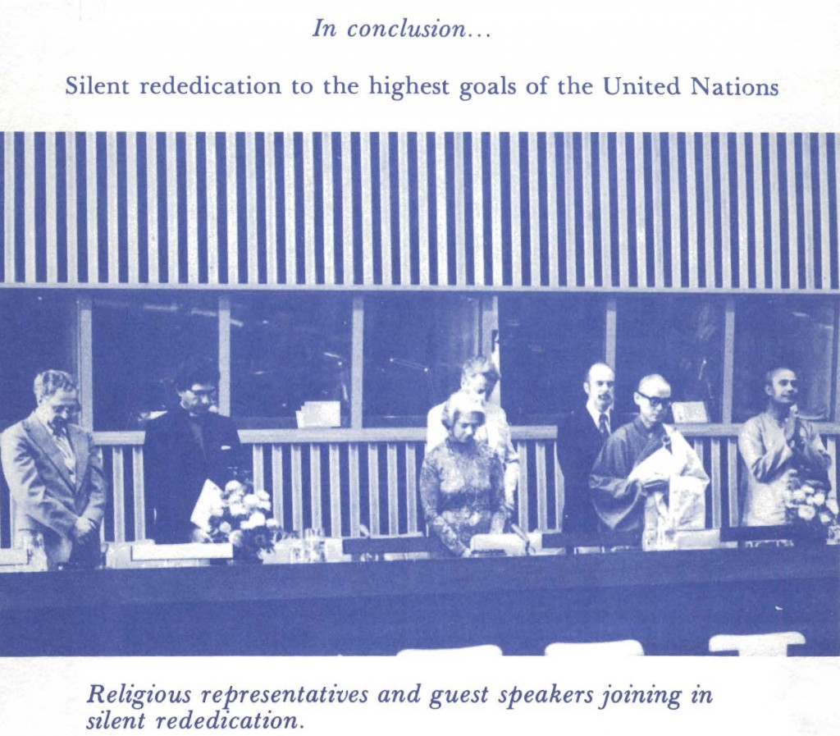](https://www.srichinmoypeacemeditationatun.org/wp-content/uploads/1975/09/bu-scpmaun-1975-09-12-30th-open-unga_P11-silent-redication-highest-goals.jpg)

[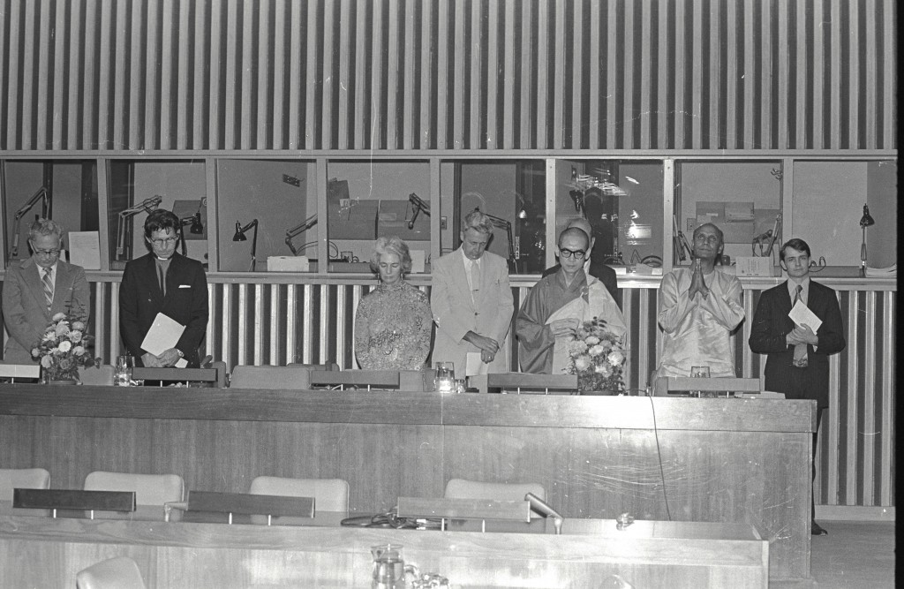](https://www.srichinmoypeacemeditationatun.org/wp-content/uploads/1975/09/75-89A-00.jpg)

**We would like to express our gratitude to the representatives Of the various missions of the United Nations who participated in** **our programme. These individuals- being directly responsible for the deliberations of the coming Assembly- enhanced our meeting with their very presence.**

The **International Cooperation for Peace Committee** is a non-formal organisation dedicated to the processes of reflection and cooperative action for world peace. Members include staff and representatives of the Secretariat, Missions and Non-Governmental Organisations of the United Nations .

[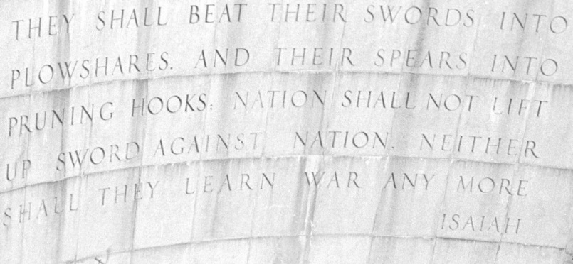](https://www.srichinmoypeacemeditationatun.org/wp-content/uploads/1975/09/75-89A-24-swords-into-plowshares.jpg)

**Article in the *Diplomatic World* on 06 October 1975,**

***Major Faiths In Program* to mark the opening of the 30th General Assembly.[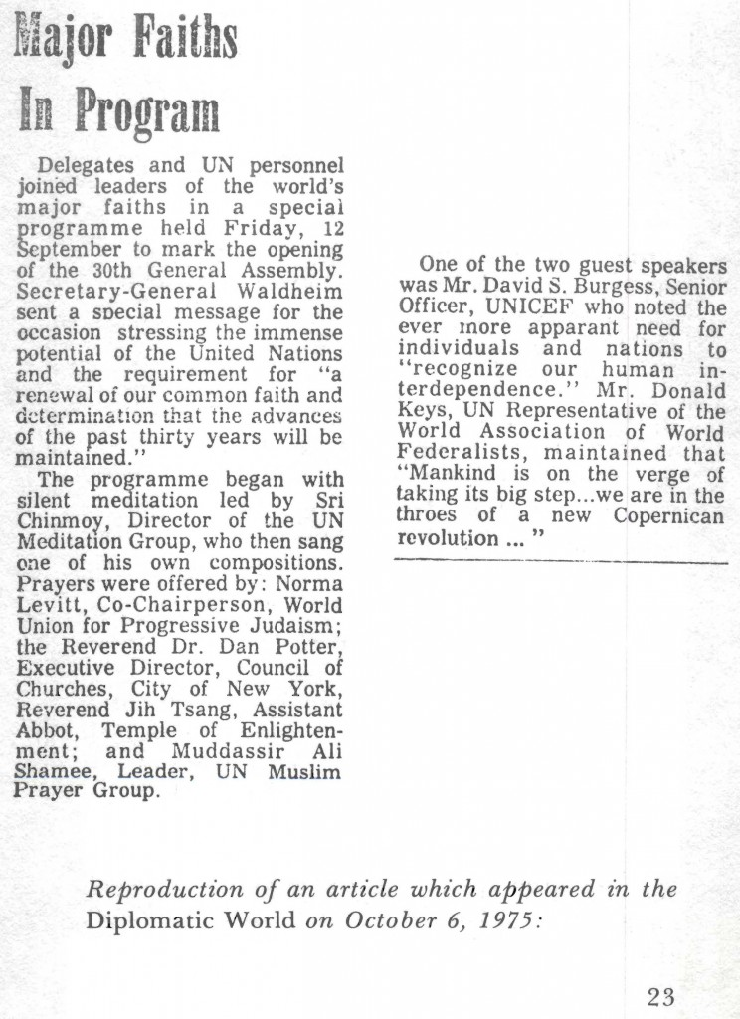](https://www.srichinmoypeacemeditationatun.org/wp-content/uploads/1975/09/bu-scpmaun-1975-09-27-vol-03-n-09-sep_P25-dip-world-major-faiths.jpg)**